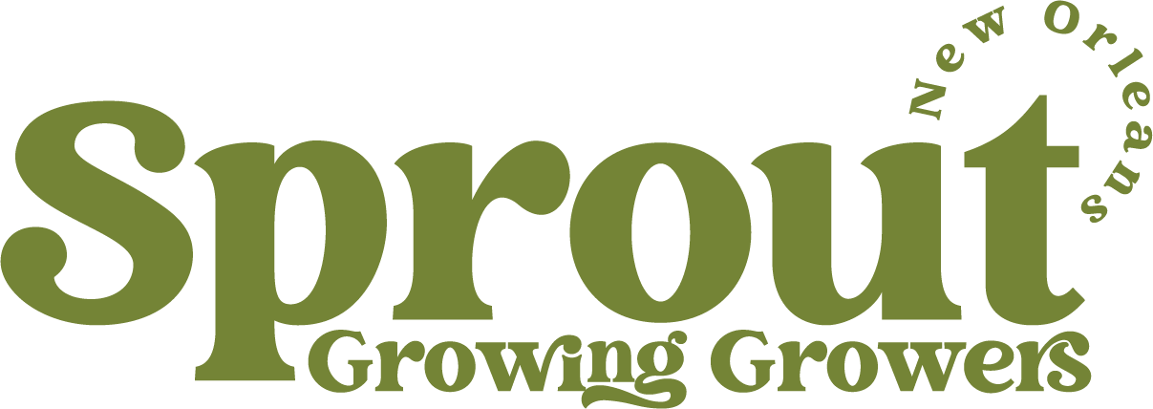 MEDIA RELEASE
CONTACT INFORMATION:
SPROUT
Marguerite Green
985-373-6188
margee@sproutnola.org
FOR IMMEDIATE RELEASE
Novo Nordisk invests $4 Million in the Louisiana Small-Scale Agriculture Coalition’s
Food Systems Programming

Agriculture is an important strategy for mitigating and adapting to the climate crisis that disproportionately affects New Orleans and the greater Gulf South. Although Louisiana is an agricultural state, production is focused on big commodities. If there were no imported food from elsewhere, there would be only enough food grown in Louisiana to feed the state population for one week.

To combat statistics like these, the Louisiana Small-Scale Agriculture Coalition (LSSAC) formed in 2022. LSSAC works to bolster the agricultural economy while supporting Louisianans struggling with food insecurity by creating low-cost access to fresh, healthy, local food. Beginning in March 2024, the coalition will embark on an exciting state-wide project to improve the capacity of the local food system. By focusing on infrastructure and technical assistance support for small-scale vegetable farmers, this program will increase the demand for and availability of local, fresh food across the state. Additionally, it will build connections between farmers and market outlets specifically for low income and food insecure residents.

“We know, from our work with both institutions and farmers, that gaps exist between the two. In order to have a strong local food system, LSSAC will work to help fill these gaps in innovative and collaborative ways so that more fresh, healthy, local food will be available for all Louisianans, including our youngest and most vulnerable,” says Elisa Muñoz, Executive Director of the Food Policy Action Council.

Funded by a 3-year $4.1MM grant by Novo Nordisk, this complex food systems program is the work of LSSAC, a coalition of seven food system organizations who work on a range of components of the food system infrastructure across Louisiana. The statewide coalition consists of long-standing partner organizations the Acadiana Food Alliance, Big River Economic Agricultural Development Alliance, Louisiana Central, Market Umbrella, New Orleans Food Policy Action Council, Shreveport Green, and SPROUT NOLA.

The team will work across institutional partners like food banks, early childhood education centers, schools, and shelters to create market pathways that can be lasting outlets for fresh food. There will be a special focus on building partnerships with food systems leaders and organizations in under-represented parts of the state like the southwest and northwest. In addition, partners are supporting the development of on-farm infrastructure so farmers can scale up, increase capacity, and have more sustainable business operations. More sustainable farm businesses will mean more fresh food across the state in perpetuity.

“At Novo Nordisk Inc. (NNI), we start and end every day driven by the mission to promote health and wellness in our communities. Through our giving we work with locally based partners, like Louisiana Small-Scale Agriculture Coalition (LSSAC), to ensure that the projects are reflective of the community’s input, expertise, and needs the community identifies,” says Jennifer Duck, Vice President, Public Affairs, Novo Nordisk Inc. “We’re proud to partner with LSSAC on meaningful solutions to improve healthy food access that will benefit the health and wellbeing of marginalized communities that will be served by this project ”.

SPROUT started when neighbors and market gardeners came together to provide community
space and training to grow food. We support established and developing small-scale and
sustainable farmers in Louisiana with technical and social support to create a more equipped
network of growers in Louisiana and access to community food systems. SPROUT strives for community control of food and to address access problems by giving locals a stake in their own food. By creating communities that revolve around local food, we take a holistic approach to nutritional justice, encouraging people to enjoy every step of the process.

###

